**CLASS DIAGRAM**

**DOCTOR**

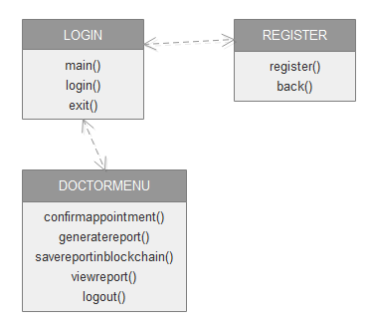

**PATIENT**

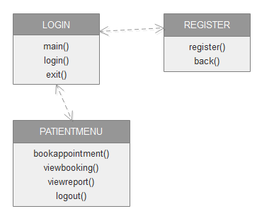

**LAB TECHNICIAN**

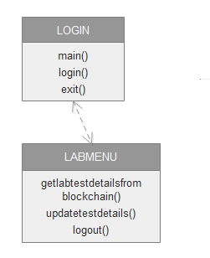

**BLOCKCHAIN SERVER**

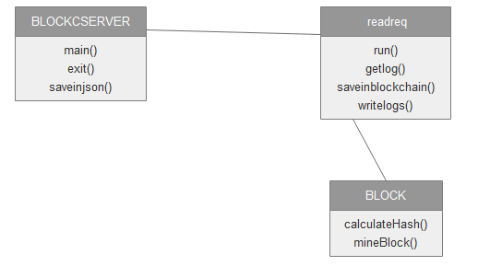

**ACTIVITY DIAGRAM**

